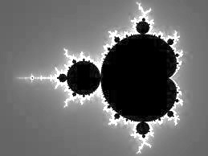
Fractals
Day 1 Exit Ticket

Name:

What is a fractal?

Which writing prompt do you plan to answer, and what is one idea you plan to include?

